Classification of living organisms
Classification key – Activity
Use a classification key to identify these living things.
Write the name of each organism below in the corresponding box.
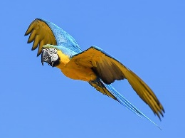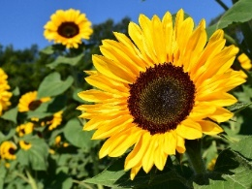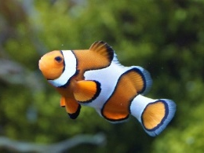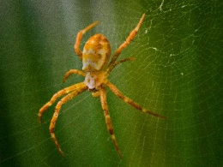
Parrot Sunflower Clownfish Spider
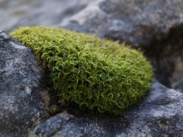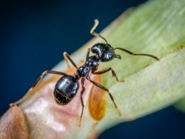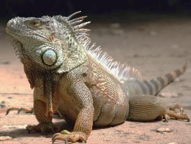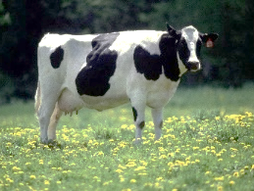
Moss Ant Iguana Cow

Can it move from one place to another?
YES
NO
NO
YES
Has it got flowers?

Has it got bones inside its body?


YES
NO
NO
YES

Has it got 8 legs?
Does it produce milk?
YES
NO


Has it got wings?
YES
NO

Can it breathe underwater?
NO
YES

